ARDON® B2B Portal User Manual
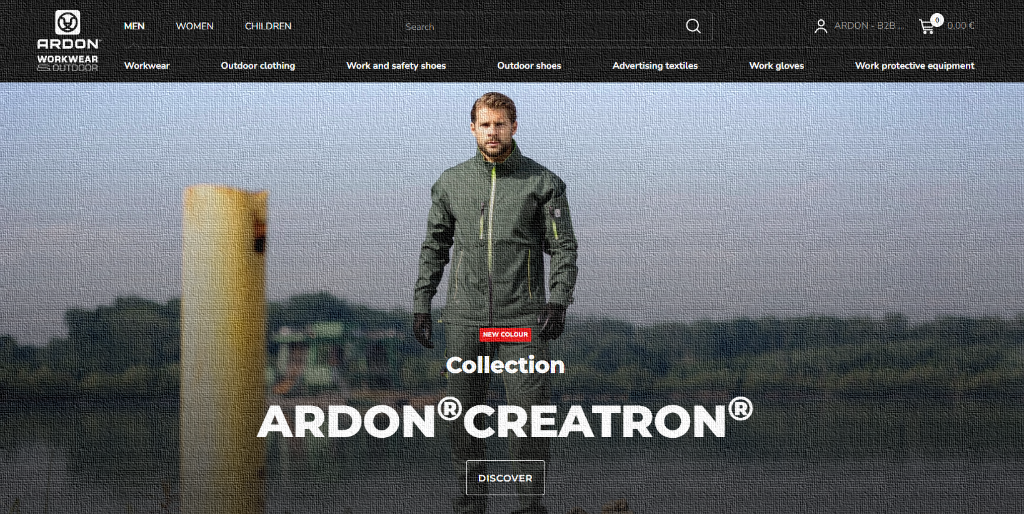
Contents

FIRST LOGIN 4
After the first login / confirmation of the Terms and Conditions and entering the Portal 6
MY ACCOUNT – USER ACCOUNT SETTINGS 7
Account Settings 7
Manage Sub-Accounts 8
Orders waiting for approval 11
My orders 12
Returns and Complaints 13
Complaints 13
Returns 14
Invoices and Credit Notes 16
Backorders section 17
Stock alert management 17
Saved carts 17
ARDON® - Downloads 19
HOW TO SHOP 20
"Multiple carts" function 21
Creating a new cart and saving it as a quick option 22
Order table 24
Product statuses and stock quantity 27
Adding to cart / purchase process 29
Order import 29
Cart / Shipping and payments 37
After sending the cart / Backorders and how we handle them 43
PORTAL SPECIFICITIES 44
Dropshipment 44
New recipients vs. dropshipment 45
Courier service fees 47
Overdue invoices 48
FREQUENTLY ASKED QUESTIONS (FAQ) 49

FIRST LOGIN

- How to log in correctly
- You received your login information = email from your ARDON® sales representative.
- The login email is unique and only one account is used with it.
- It is not possible to fill in another email; the account would not be paired with your price lists, etc.
- Log in on the www.ardonwear.com website in the “B2B User Login” section.
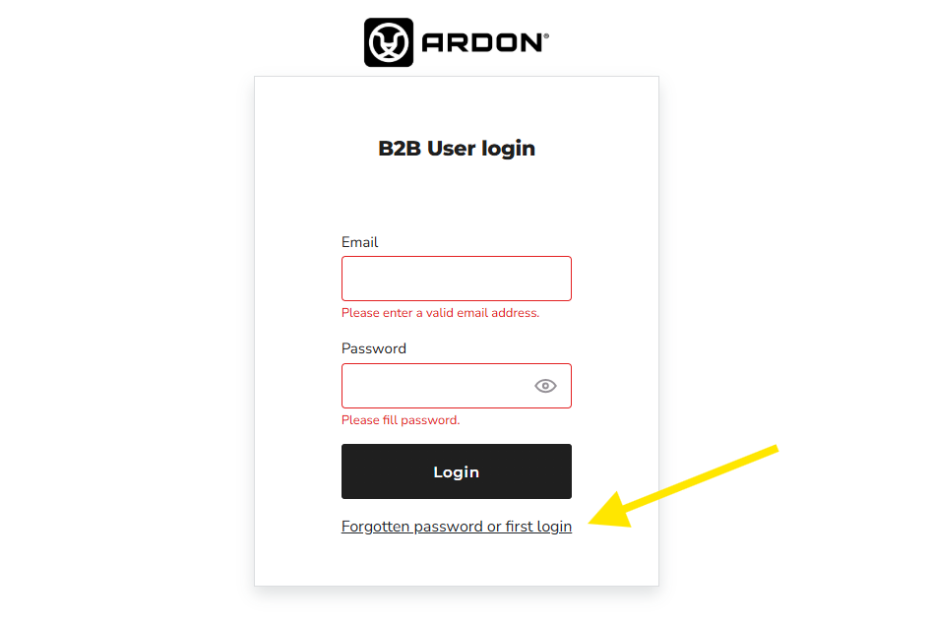
- Fill in the email that the sales representative dictated to you and then use the “Forgotten password or first login” function to set your new unique password.
- Fill in the email and wait for the password reset instruction to be sent to your email.

- You will set a new password and then log in to the B2B portal (hereinafter referred to as the “Portal”).

After the first login / confirmation of the Terms and Conditions and entering the Portal

- After the first login, a window will pop up with the General Terms and Conditions for the delivery of goods (hereinafter referred to as the “Terms”).

- After familiarizing yourself with the Terms and Conditions, you need to confirm them at the bottom by pressing the button to confirm the Terms and Conditions.

- After confirmation, you will be redirected to the Portal itself, directly to the My Account section, where you will perform the initial account settings and select various preferences, see the Account Settings section in the next section of this manual.

MY ACCOUNT – USER ACCOUNT SETTINGS

Account Settings

In the first tab, you can see your company's billing settings. You cannot change anything here, we read your data from our internal system. Only your sales manager can change the data. In case of discrepancy, please contact him or your sales representative.

On this page, you can choose to enable/disable the “Multiple Carts” function, which is introduced and explained separately in the following sections of this manual.

Confirm everything by clicking the “Save” button

Manage Sub-Accounts
- You can create sub-accounts within your account. You can add other users who will operate your account by clicking the “Add Sub-Account” button.

- Fill in the following table and the person will receive an invitation to the Portal to the selected email address, where they will be able to start logging in with their email address.

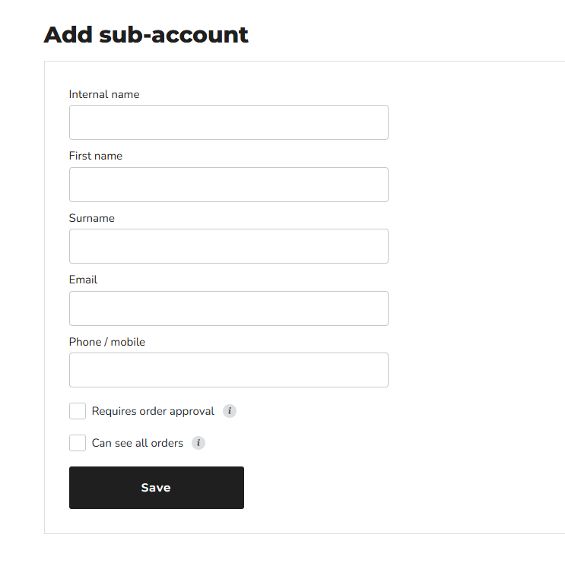

- You can enable the “ Requires order approval” function for a sub-account – if this function is enabled, after their order is placed, you – the parent account – will receive an email and a notification in your account first. You can immediately approve the order, return it with comments, or cancel it. Only after your approval does the order enter the ARDON system. If the order is not subject to approval, it has the same powers as you – the main account. From the point of view of the Terms and Conditions, we always consider an order sent from all subordinate accounts as if it had been sent by the main account.

- You can also enable the “ Can see all orders” function for the subordinate account. Imagine that you have 3 accounts in the company. If you have this function enabled, everyone can see all orders. If you do not have the function enabled, they only see the orders that they themselves have placed. The main account automatically sees all orders.

Orders waiting for approval

- This section is relevant only for those users who use the subaccounts function.

- In this section, individual accounts can see an overview of orders for approval. The subaccount is waiting for the action of the main account. The main account can approve, return, or cancel orders.

- After the order is processed for approval by the main account, this order is moved to the "My orders" section for all users.

My orders

- This section shows an overview of orders, their number, any internal order number (i.e. your order number - this flag will subsequently be transferred to the invoice), the creation date (or if it is not an order created by you, then the flag of which sub-account within your B2B account created it), the order value and the order status, what state it is in.

- There is also a full-text search engine. You can find orders containing this product by name or product code, time period, order number, etc.

- From the clicked-out order detail, you can then perform an action such as a complaint or return.

- In the upper part, you can use the Import order button to create a new order by importing. Import is explained in a separate section in the manual.

Returns and Complaints

WE ARE PREPARING – NOW UNAVAILABLE

- In this section you can see the documents for Complaints and Returns. Just like in the order history, you can enter a new complaint and a new return here.

Complaints
- To file a complaint, you must know the order number from which you are making a complaint. If you do not know the order number, we recommend using the search engine within the My orders module, find the order containing the given product and file a complaint in this way.

- For the complaint, you select the order number, item, quantity, describe the reason for the complaint and add a photo of the complained item as an attachment.

- Only one item can be selected for the complaint. If you have more than one product to complain about, you must create a complaint for each product separately, because each complaint is a unique case. It cannot be solved in bulk.

- By clicking "Send", a new complaint will be created, which we will register from that moment on. You will receive confirmation of the creation of a new complaint by email.

Returns

- Returns are also entered in this module.

- We look at each return request on a case-by-case basis and do our best to find a fair solution. We may accept or decline a return based on our own conditions. A return fee may be charged.

- Goods purchased no later than 1 year ago can be returned. The system monitors this. Of course, there will be a transitional period between the start of using the system and the return period. You will not find the order history outside this B2B portal in your account.

- Items marked with the status SALE cannot be returned. This status is visible at the time of purchase in the order table, in the order confirmation, in your account, etc. The system will not allow a product marked in this way to be returned.

- Here you can also see the values for turnover and returns. They are transferred from the ERP, so you will see the current numbers regardless of the order history from the Portal.

Invoices and Credit Notes

WE ARE PREPARING AN EDITION

- In addition to the current invoice receiving mode that you are used to, you will also find invoices in PDF format in these sections.

- Only the invoice and credit note that were created in the system will be uploaded to this section. If your sales manager "clusters" several orders into one document, you will not find such an invoice here, because it is not related to the created order. You will receive such an invoice by email.

Backorders section
WE ARE PREPARING THIS SECTION FOR YOU

Stock alert management

- Here you can see the items for which you have marked the stock alert function, i.e. email notifications when the monitored item is put into stock.

Saved carts

- If you have the multiple cart function turned on, you can manage them here. Add, remove, edit them, etc. If you see the "permanent cart" flag, you have saved it as a quick option.

- More information about saved carts can be found in the separate "Multiple carts" section in this manual.
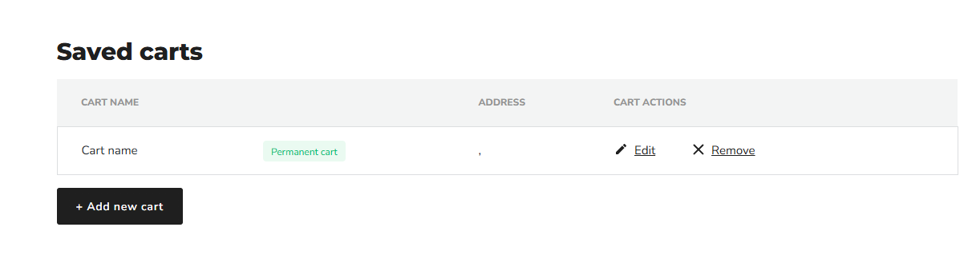

ARDON® - Downloads

- In the downloads section, you can find various ARDON® documents, which you can download yourself here.

- Here you will find catalogs, declarations of conformity, technical sheets, instructions, certificates, etc.

- If you have a signed license agreement, you will also see the Photo Gallery section, from which you can download photos. If you want to have this section accessible, contact your sales representative with a request for a license agreement.

HOW TO SHOP

- After you have created an account, the actual shopping process can begin.

- You can shop in an e-shop style - i.e. by "browsing" the categories, searching for a product (you search either via the search engine or via categories with rich filtering options), etc., or you can use the Import order button. This is covered in a separate section of this manual.

- Before the first shopping process, we recommend that you choose in your Account settings whether you want to use the "Multiple carts" option.

"Multiple carts" function
- The multiple carts function allows you to create multiple orders at once according to recipients. In practice, this means that you fill multiple carts for multiple customers at the same time. If you have this function enabled, before adding the goods to the cart, the system will ask you which cart you want to put the goods in.

- If you do not have this function enabled, you fill one cart and create one joint order. In this case, the system does not ask you for the recipient at the beginning of the shopping process and you only decide on the delivery address in the last step of the cart.
- We recommend that you set up recurring carts (orders) at the beginning and save them to speed dial. They will then be offered to you when determining the cart for shopping.

Creating a new cart and saving it as a quick option
- Click on the icon / account name to select the "Saved Carts" tab

- Then press "Add New Cart" and continue according to the instructions in the image below:
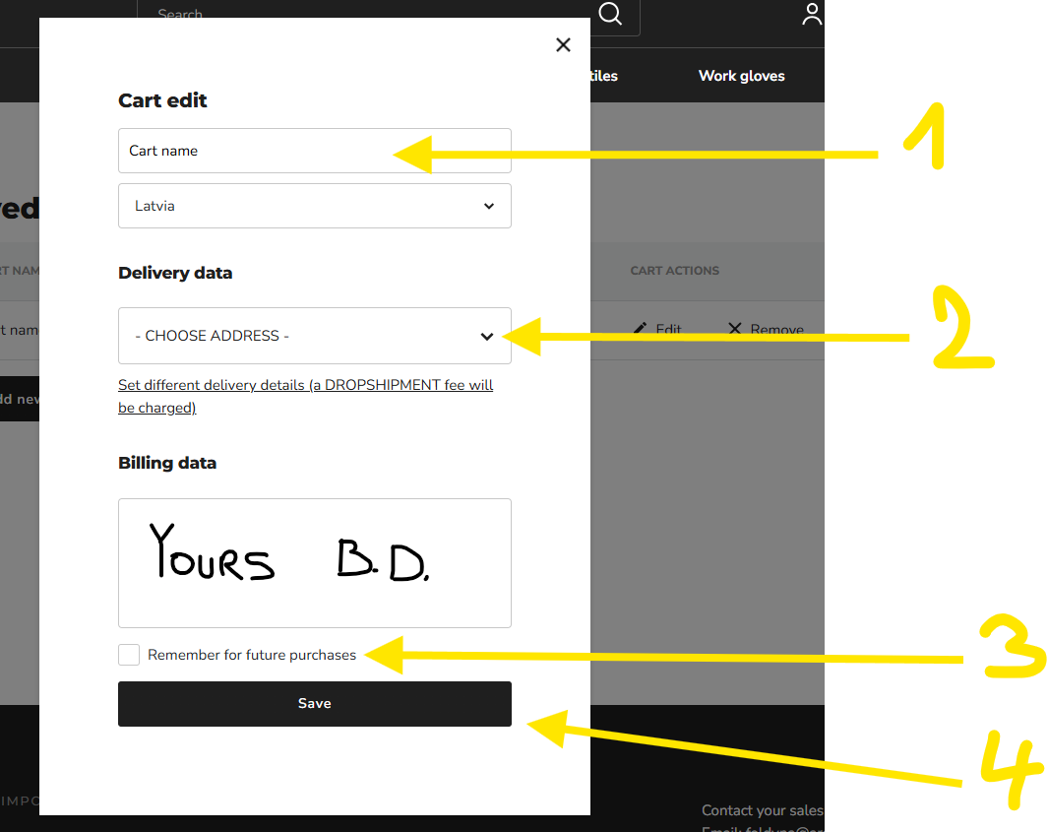
- This way you will save all your recipients that you normally serve (if you serve one, fill in this one, or you can turn off the "Multiple Carts" function in "Account Settings")

- You can return to the section at any time and edit, delete, add, etc. all Saved Carts.

Order table

- When purchasing individual items, you will encounter an order table, where you can purchase all variants of the given product in bulk "with one click".

- In the top bar of the table, you can switch between up to three units - PCS, Packages, Cartons.

- For some products, there are minimum order quantities that the system respects.

- For example, gloves, you will commonly encounter the fact that the min. order quantity is a package, i.e. 12 pairs. For most products, you can then switch to cartons and order an original carton (this is in case you want a carton of Julius gloves, for example, but you can't remember whether they are packaged in 120 or 144 pairs).

- By adding the "+" button, the units will jump in minimum multiples. So, for example, if you select 1 carton of Julius gloves, you will see 12 packages and 144 pairs at the same time.

- In some cases, the system will force you to switch to a different minimum quantity tab (e.g. from PCS to Package; or from Package to Carton). If neither product variant is delivered in pieces, the packaging section will be offered as the smallest allowed unit for purchase.
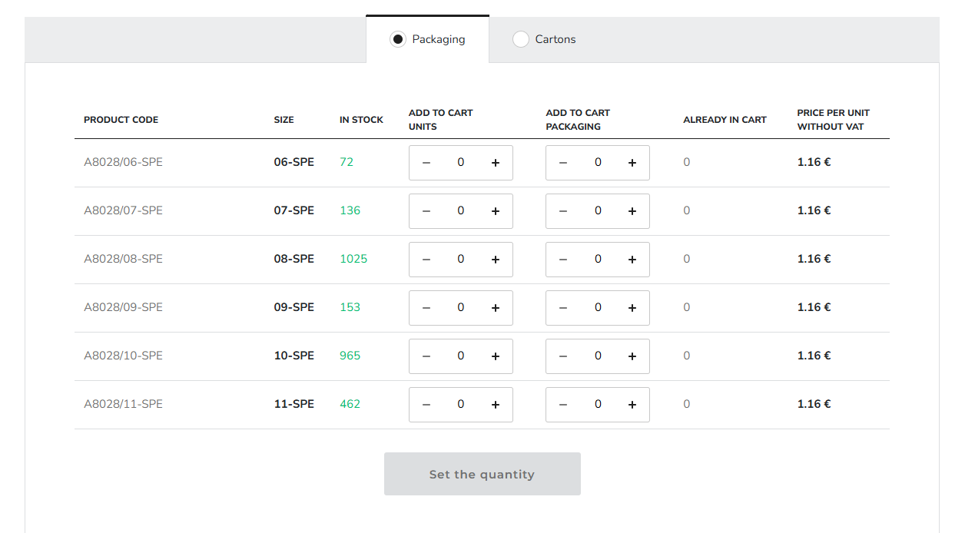

Product statuses and stock quantity
- You may encounter product statuses such as New Collection, Sale, On order.

- For example, the Sale status is important - such a product cannot be returned (it will not be possible to select such a product in the return module).
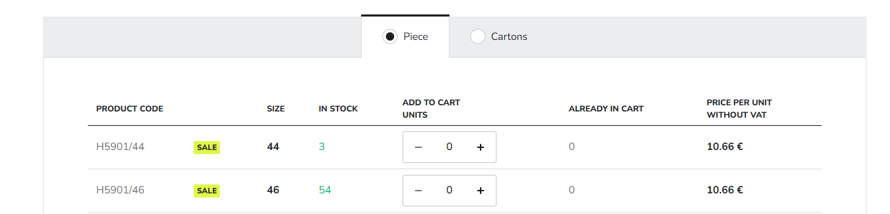

- In the in stock column, you can see the quantity that is available to you at the time of purchase

- For products that are not in stock and for which the quantity and next stocking date are known, this information is listed.
- (WE WILL ADD MORE INFORMATION TO THIS SECTION, SUCH AS, IN ADDITION TO THE FIRST NEAREST DATE, OTHER STOCKING DATES ARE ALSO SET AND THE NEXT STOCKING DATES ARE DISPLAYED FOR STOCK ITEMS AS WELL)

- These products with a stock level of 0 can be added to the cart. This will create a reservation for the product, which will be processed at the time of stocking.

- Alternatively, you can use the "stock alert" function to set notifications when the product is in stock. You will receive an email that we have put the watched item in stock.

Adding to cart / purchase process

- After you have selected the product, the adding to cart phase comes. After pressing "Add to cart", you will be prompted to select a cart if you are using the "Multiple carts" function. If you have set up quick dials, you will see them here.

- If you do not have any quick dials saved, you must select "Create new cart". Here you can also set up saving the cart for future quick dialing.
- The easiest and fastest way to make a bulk purchase is "Import order"

Order import

- You can import an order by clicking the "Order import" button after hovering your mouse over the empty cart icon in the Portal header.

- If you are using the "Multiple carts" function, you must first fill in the recipient. If not, the entire file will be imported into one common cart.
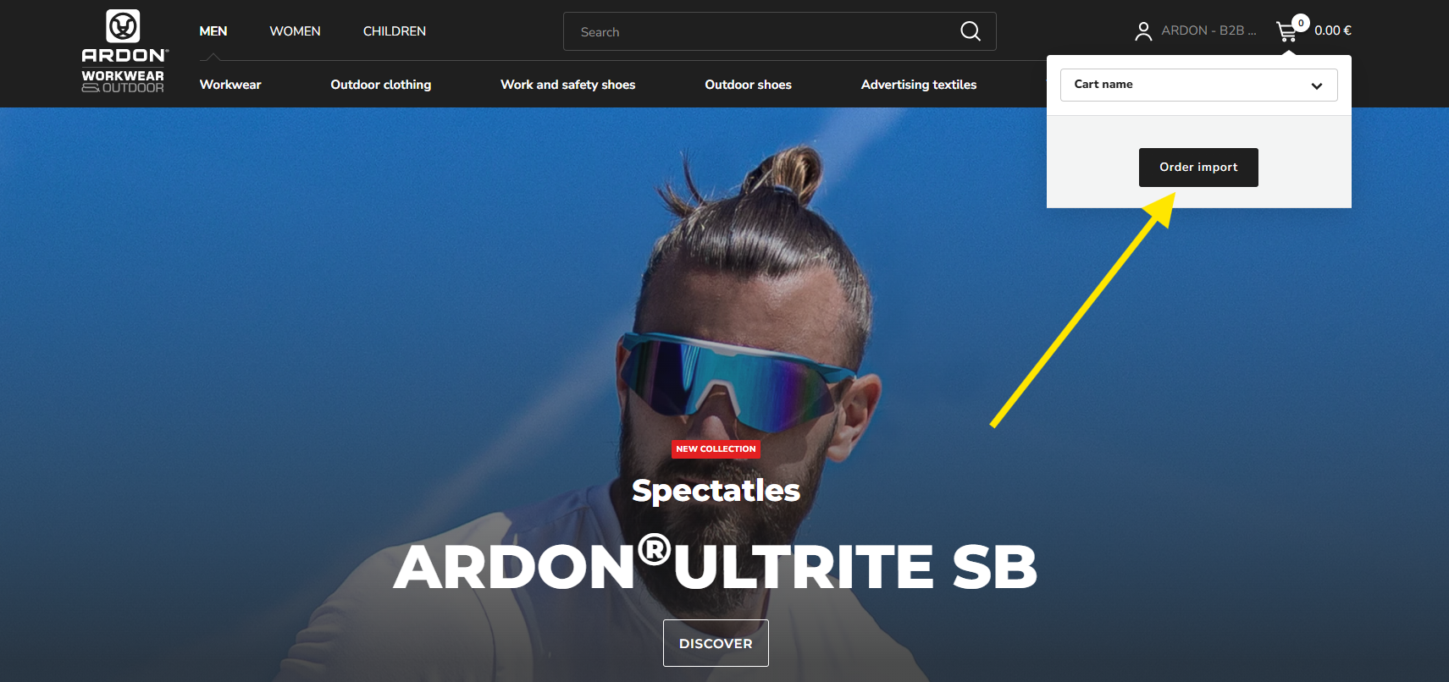

- The import is done via an Excel file and is very simple and intuitive. There is a sample document directly in the section, multiple formats are allowed (XLXS, CSV), and for CSV you can choose the separators.

- We recommend a classic XLXS document with two columns: in the first column (A) the product code / its variant; in the second column (B) the quantity
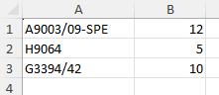

- You save the file (for example, to your desktop) and insert it into the B2B portal using the "select file" button.

- After loading the file, a message will pop up stating that the import was successful and the goods will be added to the cart, where you can continue the order process.

- If the import detects an error, it will notify you of this (item not found, incorrect quantity, etc.). It is necessary to respect the product codes, including their variants. For example, pay attention to the product Wooden shoehorn ARDON®CP4, which has the article code: H1509/H1509 (adding only the code H1509 will not import). However, the system will warn you about this.

- If the minimum order quantity of the given article does not match, the import will round the required quantity up to the nearest allowed unit.

For example:
Buck gloves can only be purchased in packs (i.e. in multiples of 12 pairs). If you write in the order form that you want 20 pairs, the system will automatically add 24 pairs (= 2 packs of 12 pairs). The system will warn you about this fact.

- Below is a graphic example of the entire import:

I created a file "import.xlsx" on my PC in Excel.
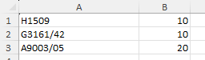
I wrote the following items in it:
- I selected the file using the "Select file" button. Then I press “Import”
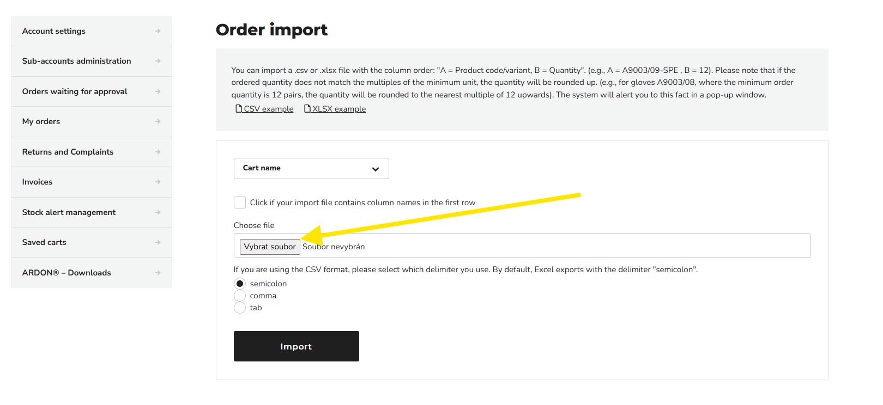
After pressing it, you can see that the “wheel” is spinning and the system is importing data. It then generates an import evaluation:
Out of 3 products, 2 were imported into the cart and for one of them the quantity was changed to the closest allowed quantity – A9003/05. 1 product was not added at all due to the variant not found (product H1509).
I can manually find the missing product H1509 and add it to the cart, or correct the code in the import file and import the entire file again.
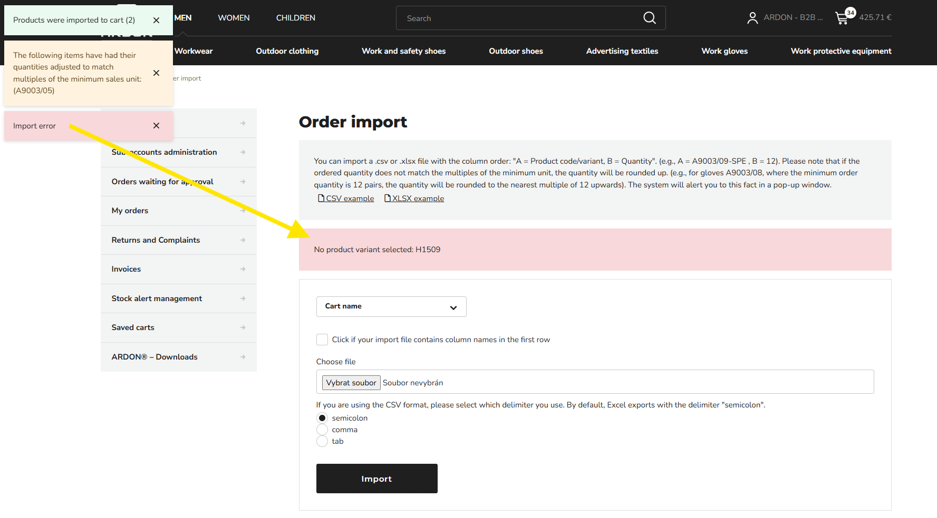

Attention: Each new import will delete the existing contents of the cart. The system will notify you of this.

After filling the cart as required, you will switch to the cart and proceed with the standard shopping process.

Cart / Shipping and payments
- After filling the cart – either manually or by import – you will select delivery and payment.

- In the first step of the cart, you will see a warning that the goods added to the cart are not reserved. Therefore, do not delay your purchase. Before the final sending of the order, the system will recalculate the current stock and if the item is sold out between the time of adding it to the cart and its shipment, you will be notified of this fact.

- The goods will be kept in the cart for 30 days. If you do not close the cart within 30 days, its contents will be deleted. This function is useful for those of you who are used to fulfilling the order gradually until the delivery is closed.

- At the time of closing and sending the order, it is no longer possible to change the order in any way, add or remove products. The order is binding and will be processed as such.
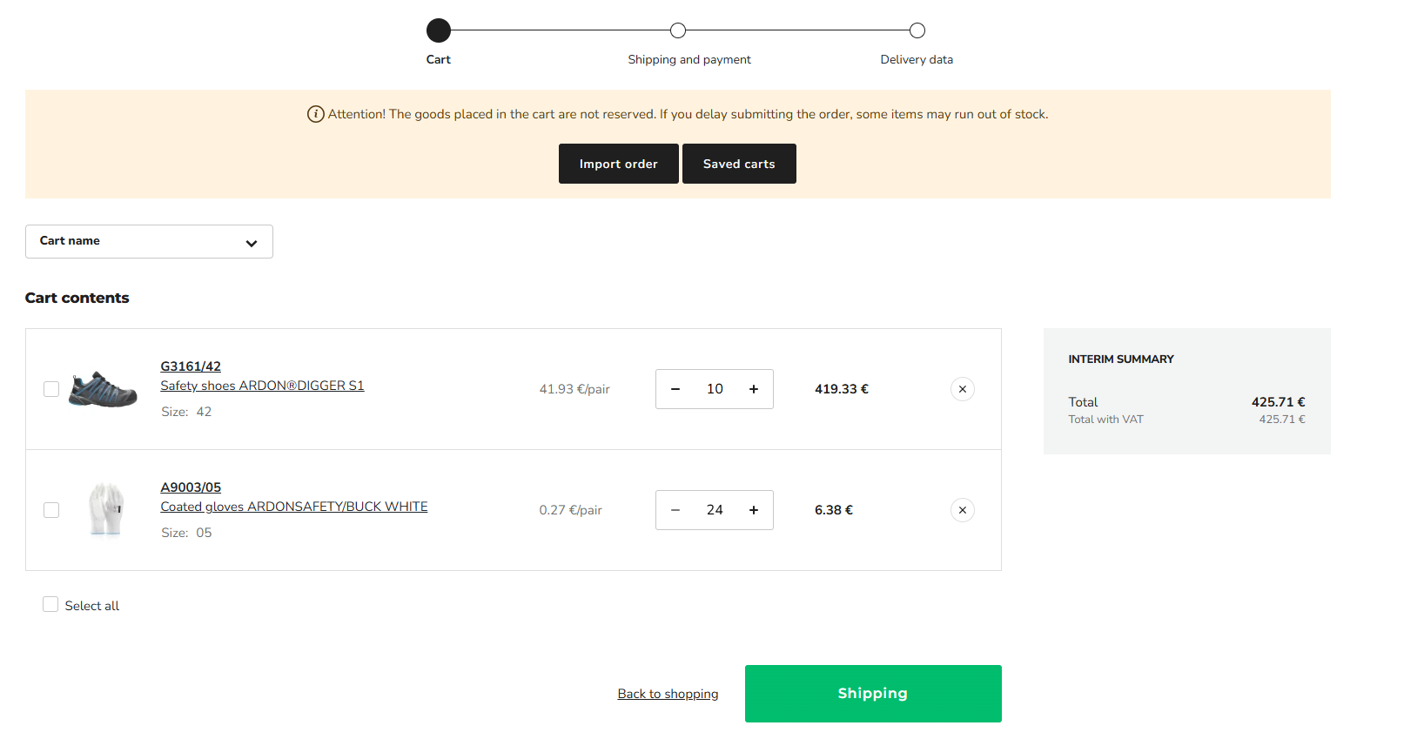

- In the next step of the cart, you choose Shipping. There are 2 types of shipping:
Self-collection and Courier service according to the current offer.

- Then, select the payment type according to the current offer.

- After selecting the type of delivery and payment, you will be taken to the last step of the cart, where you will confirm the billing and delivery address and submit the order.
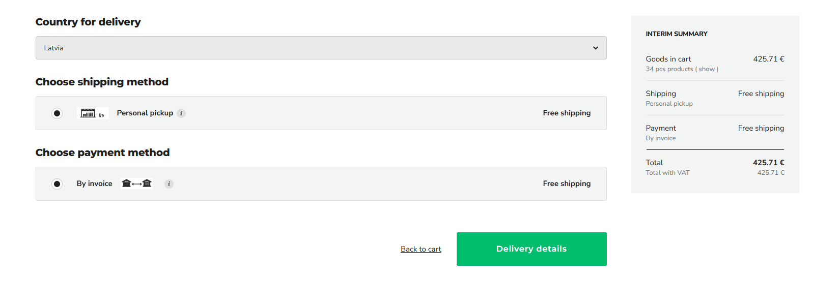

- The billing address is always non-editable.

- If you use the "Multiple Carts" function, the delivery address respects your selection from the first phase of the purchase, when you had to choose a cart. This is a check that the entire purchase was made to the desired recipient. This can also be changed here if the recipient was entered incorrectly.

- The system offers you your recipients that you have historically used before launching the Portal (if you are not a new customer). You can select them in the Delivery Address section by clicking the arrow to open the drop-down menu.

- You can also see the option "Set different delivery details (a DROPSHIPPMENT fee will be charged)". This option allows you to send goods to an address that you do not have in your receipts, e.g. directly to your customer. We will discuss this in a separate chapter Dropshipment.

After sending the cart / Backorders and how we handle them

- Of course, you can also order goods that we do not have in stock on the Portal.

- Such goods are marked in red in the cart and the system will ask you how you want to handle such goods. You have two options to choose from.

- If you do not want to keep backorders, click "Remove unavailable items" and these will be removed from the cart. We will then deliver the remaining goods that are in stock = no backorders are created

- In the second case, i.e. if you want to keep the backorders, press the "Split order" button. At the end of the process, the order will be divided into two partial orders, each with its own unique number. One will be covered immediately; the other will be covered gradually as soon as the items are in stock. This is a classic record of backorders, as you have been used to until now. You will also see such backorders in the Backorders section.

PORTAL SPECIFICITIES

Dropshipment
- Dropshipment is a service where we - ARDON - deliver goods to your end customer.

- You order from us, we prepare, pack and send from our warehouse directly to your end customer. There is only an ARDON delivery note in the box. You will receive the invoice to your mailbox, as standard, as you have been used to until now.

- Current recipients who meet this criterion have been marked in this way in the system and this is how we approach them.

- If you want to deliver to an address other than the one selected by your recipients, select "Set different delivery details (DROPSHIPMENT fee will be charged)" during the purchase process.

- We charge a fee for this service, which is part of the shipping fee (courier services).

New recipients vs. dropshipment
- If you need to create a new or edit an existing recipient - i.e. an address for selection from the drop-down menu - you must contact your sales manager (you can find his contact information in the footer of the Portal), who will make the change in our ERP. All changes made in the ERP will be reflected no later than 24 hours after the change is made.

- If you were to create the address yourself using the "Set other delivery details" function, this address will be considered a dropshipment.

- All dropshipment orders will be assigned to the universal recipient "dropshipping", which reflects the partner price list.

- If any of your recipients is now incorrectly marked as dropshipping, contact your sales manager, who will remove this flag from the recipient.

Courier service fees
- The price per package varies depending on whether it is a standard recipient or a recipient according to the specifics of dropshipping

- The price per package is always charged regardless of the order amount

- The shipping price depends on the weight of the shipment. After exceeding the set weight limit for 1 package, the shipping price will automatically increase. Since the system only takes into account the weight limit, it may happen that the system evaluates the shipment as, for example, 5 packages, charges them, but the shipment physically arrives in 6 packages, or even only in 4 packages. The shipping price still remains binding according to the value presented in the cart at the time of purchase.

Overdue invoices
- If we register an overdue invoice, the system will block the possibility of further ordering goods. In the first step of the cart, it will not be possible to continue and therefore the order will not be able to be sent
- We strongly recommend not leaving the payment until the last day of maturity. Matching the credited payment can take up to 2-3 business days. Payment of the invoice is defined by us as matching the payment from the bank to our ERP.

- Accepting orders other than through the B2B portal will no longer be possible.

FREQUENTLY ASKED QUESTIONS (FAQ)
We are preparing this section for you.

